Lorton American Legion Post 162
8210 Legion Drive
Lorton, Virginia 22079
Valegion162.org
Phone: 703-690-1107 Facebook: lortonlegion162

March 2024 NEWSLETTER


American Legion Post 162 Leadership:
Legionnaires  Commander: Chris Warner  First Vice Commander: Brittany Garcia  Second Vice Commander: Michelle Gill  Third Vice Commander: VACANT  Finance: Sean Counihan  Chaplain: Joe Wojtyna  Historian: James Mayfield  Sergeant At Arms: Robert Hicks  Adjutant: Eric Bach  Service Officer: VACANT  Trustees: Dewitt Duggar  Board of Directors: All above officers plus the following: Ken Witmer; Chris Young; Sam Ramseur; Dave Albert | Auxiliary  President: Jessie Haynes  First Vice President: Sandy Haynes  Second Vice President: Les Rizzo  Secretary: Vickie Pickering  Treasurer: Kelly Owens  Historian: Lori Mills  Chaplain: Jamie Edwards  Sons of the American Legion (SAL)  Commander: John Powell  First Vice Commander: VACANT Second Vice Commander: VACANT  Chaplain: VACANT  Adjutant: VACANT  Finance: VACANT  Historian: Stan Williams  Sergeant At Arms: John Yaksima

March 2024
SUNDAY | MONDAY | TUESDAY | WEDNESDAY | THURSDAY | FRIDAY | SATURDAY
 |  |  |  |  | 1 | 2
3 | 4  Aux Meeting 6PM | 5 | 6 | 7 | 8 | 9
10  Birthday Week 4th Annual  Chili Cookoff 2PM  3PM Cornhole Tournament | 11  Birthday Week | 12  Birthday Week  ExCom Mtg. 6PM  Trivia Night 7PM | 13  Birthday Week | 14  Birthday Week  General Mgt 6PM | 15  Birthday Week  Karaoke 8-12 | 16  Birthday Week  Legion Birthday Party  Dinner and Drinks 6PM
17 | 18 | 19 | 20 | 21 | 22  Gaming Tournament  7PM | 23
24  Ron Thayer 3PM | 25 | 26 | 27 | 28  Trivia Night 7PM | 29 | 30
31

EASTER

UPCOMING EVENTS
Legion Birthday Week March 10-16th
March 10th Chili Cookoff 2PM
Cornhole Tournament 3PM
March 12th ExCom Meeting 6PM
Trivia Night 7PM
March 15th Karaoke 8PM
March 16th Legion Birthday Party 6PM
March 22nd Gaming Tournament 7PM
March 28th Trivia Night 7PM

Please make sure you have your membership card every time you come in as we will be asking to see it.
2024 CARDS ARE IN! PLEASE PAY YOUR DUES
GAMING UPDATE:
This is a reminder that the gaming machines are for Members ONLY! You MUST be 21 to gamble.
Order a Brick for our memorial for your loved one. Bricks are $50. Please see the bartender for the order.
Our banquet hall is ready for your next event!
See the bartender on duty to book!

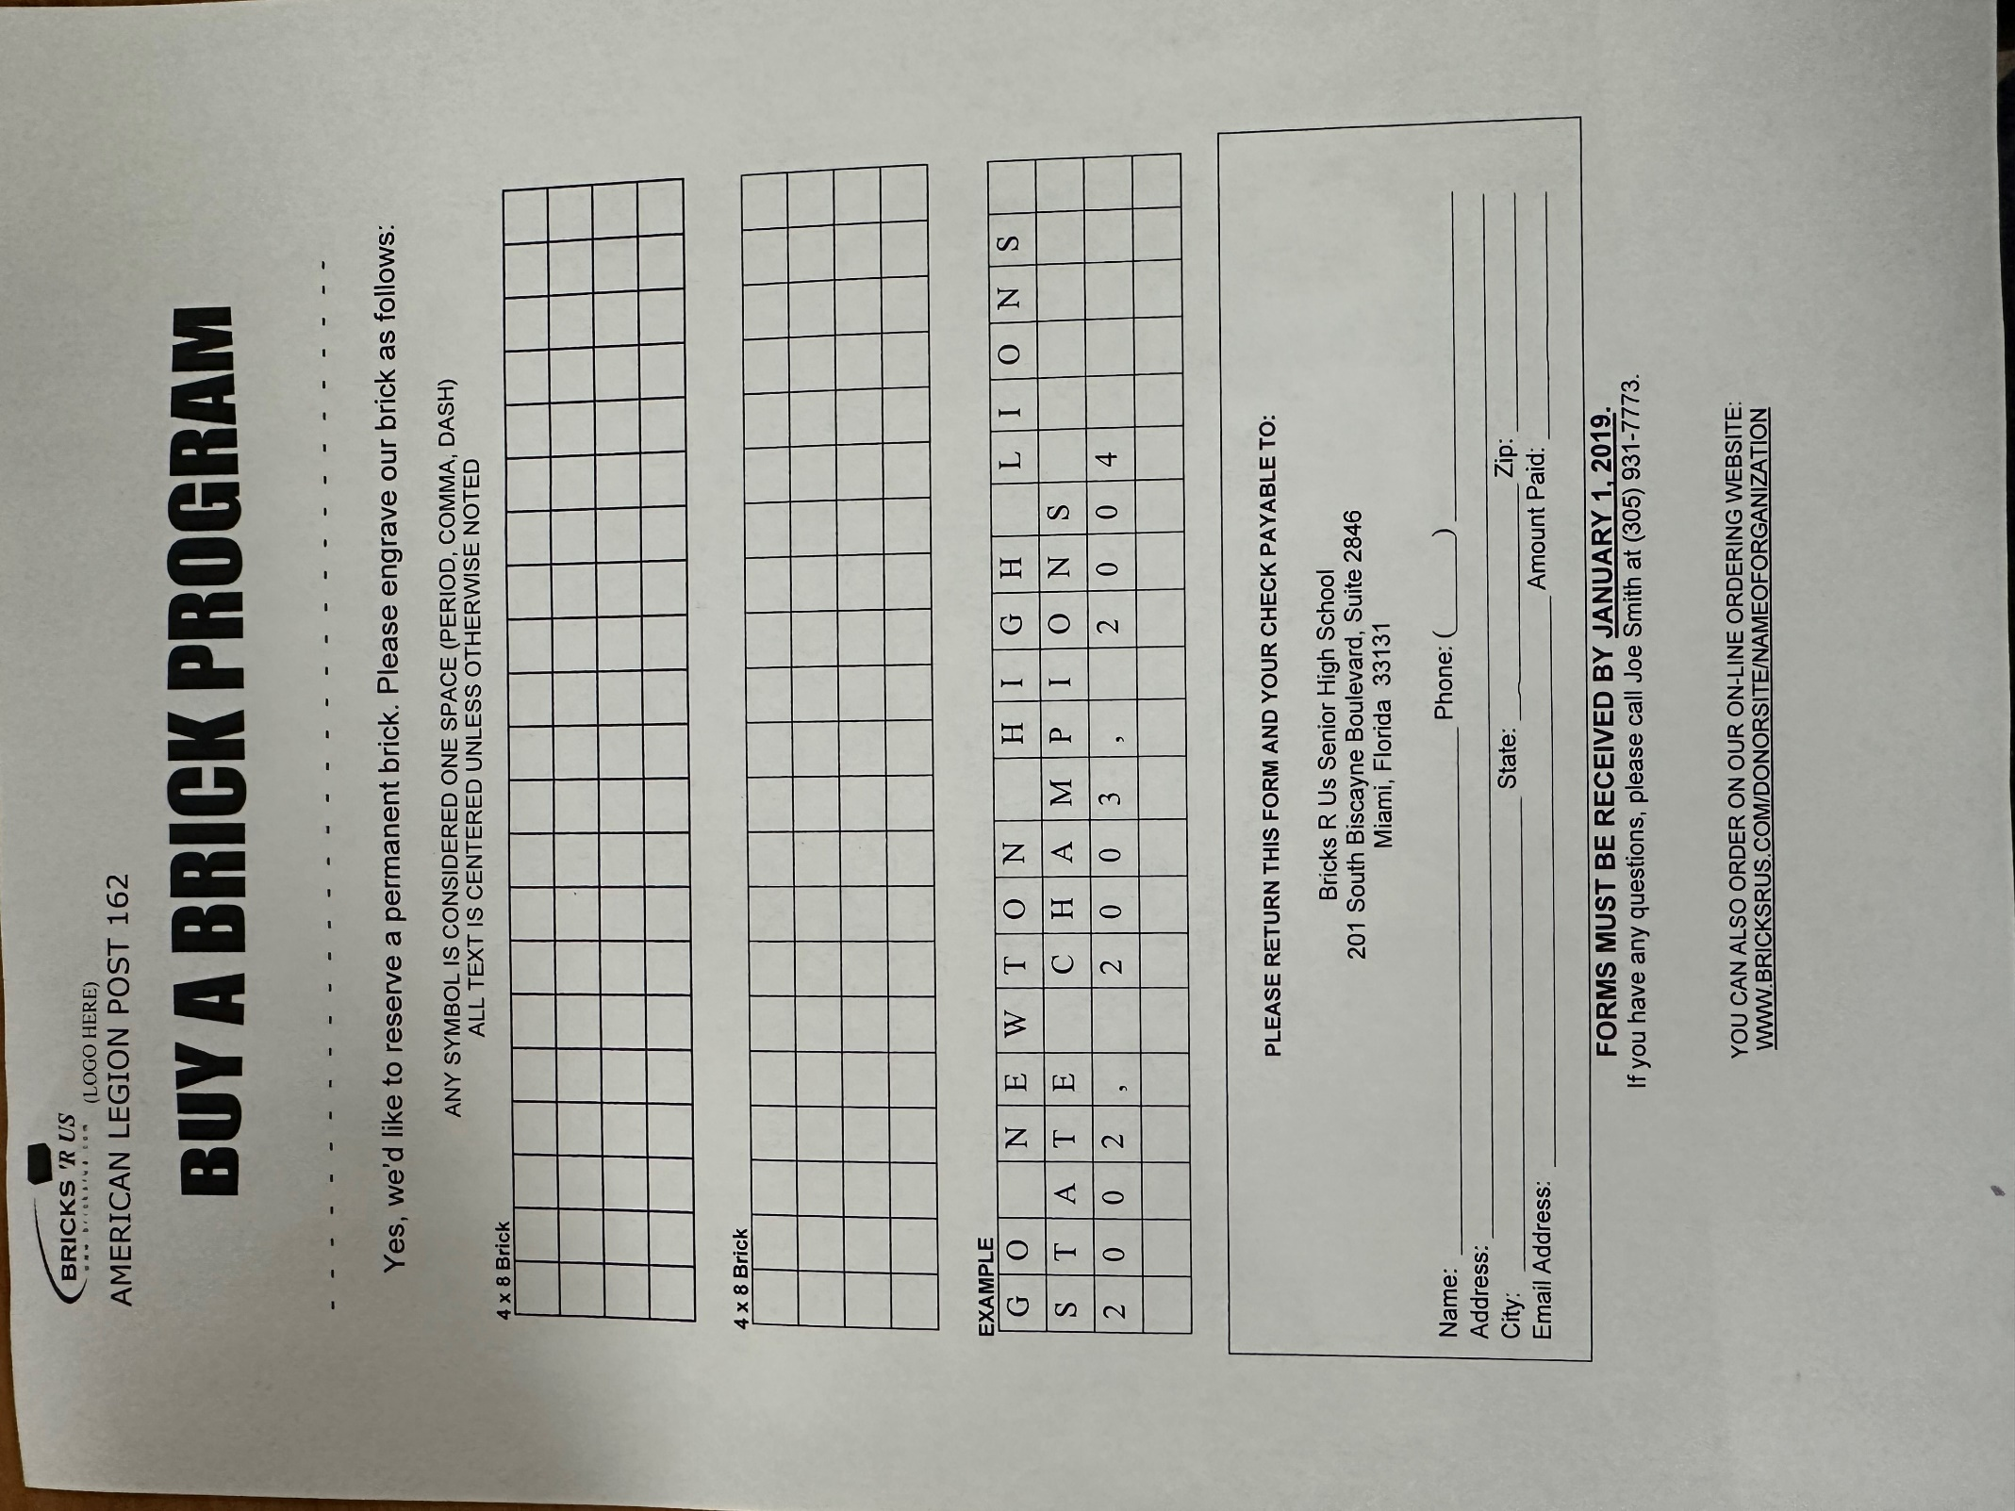

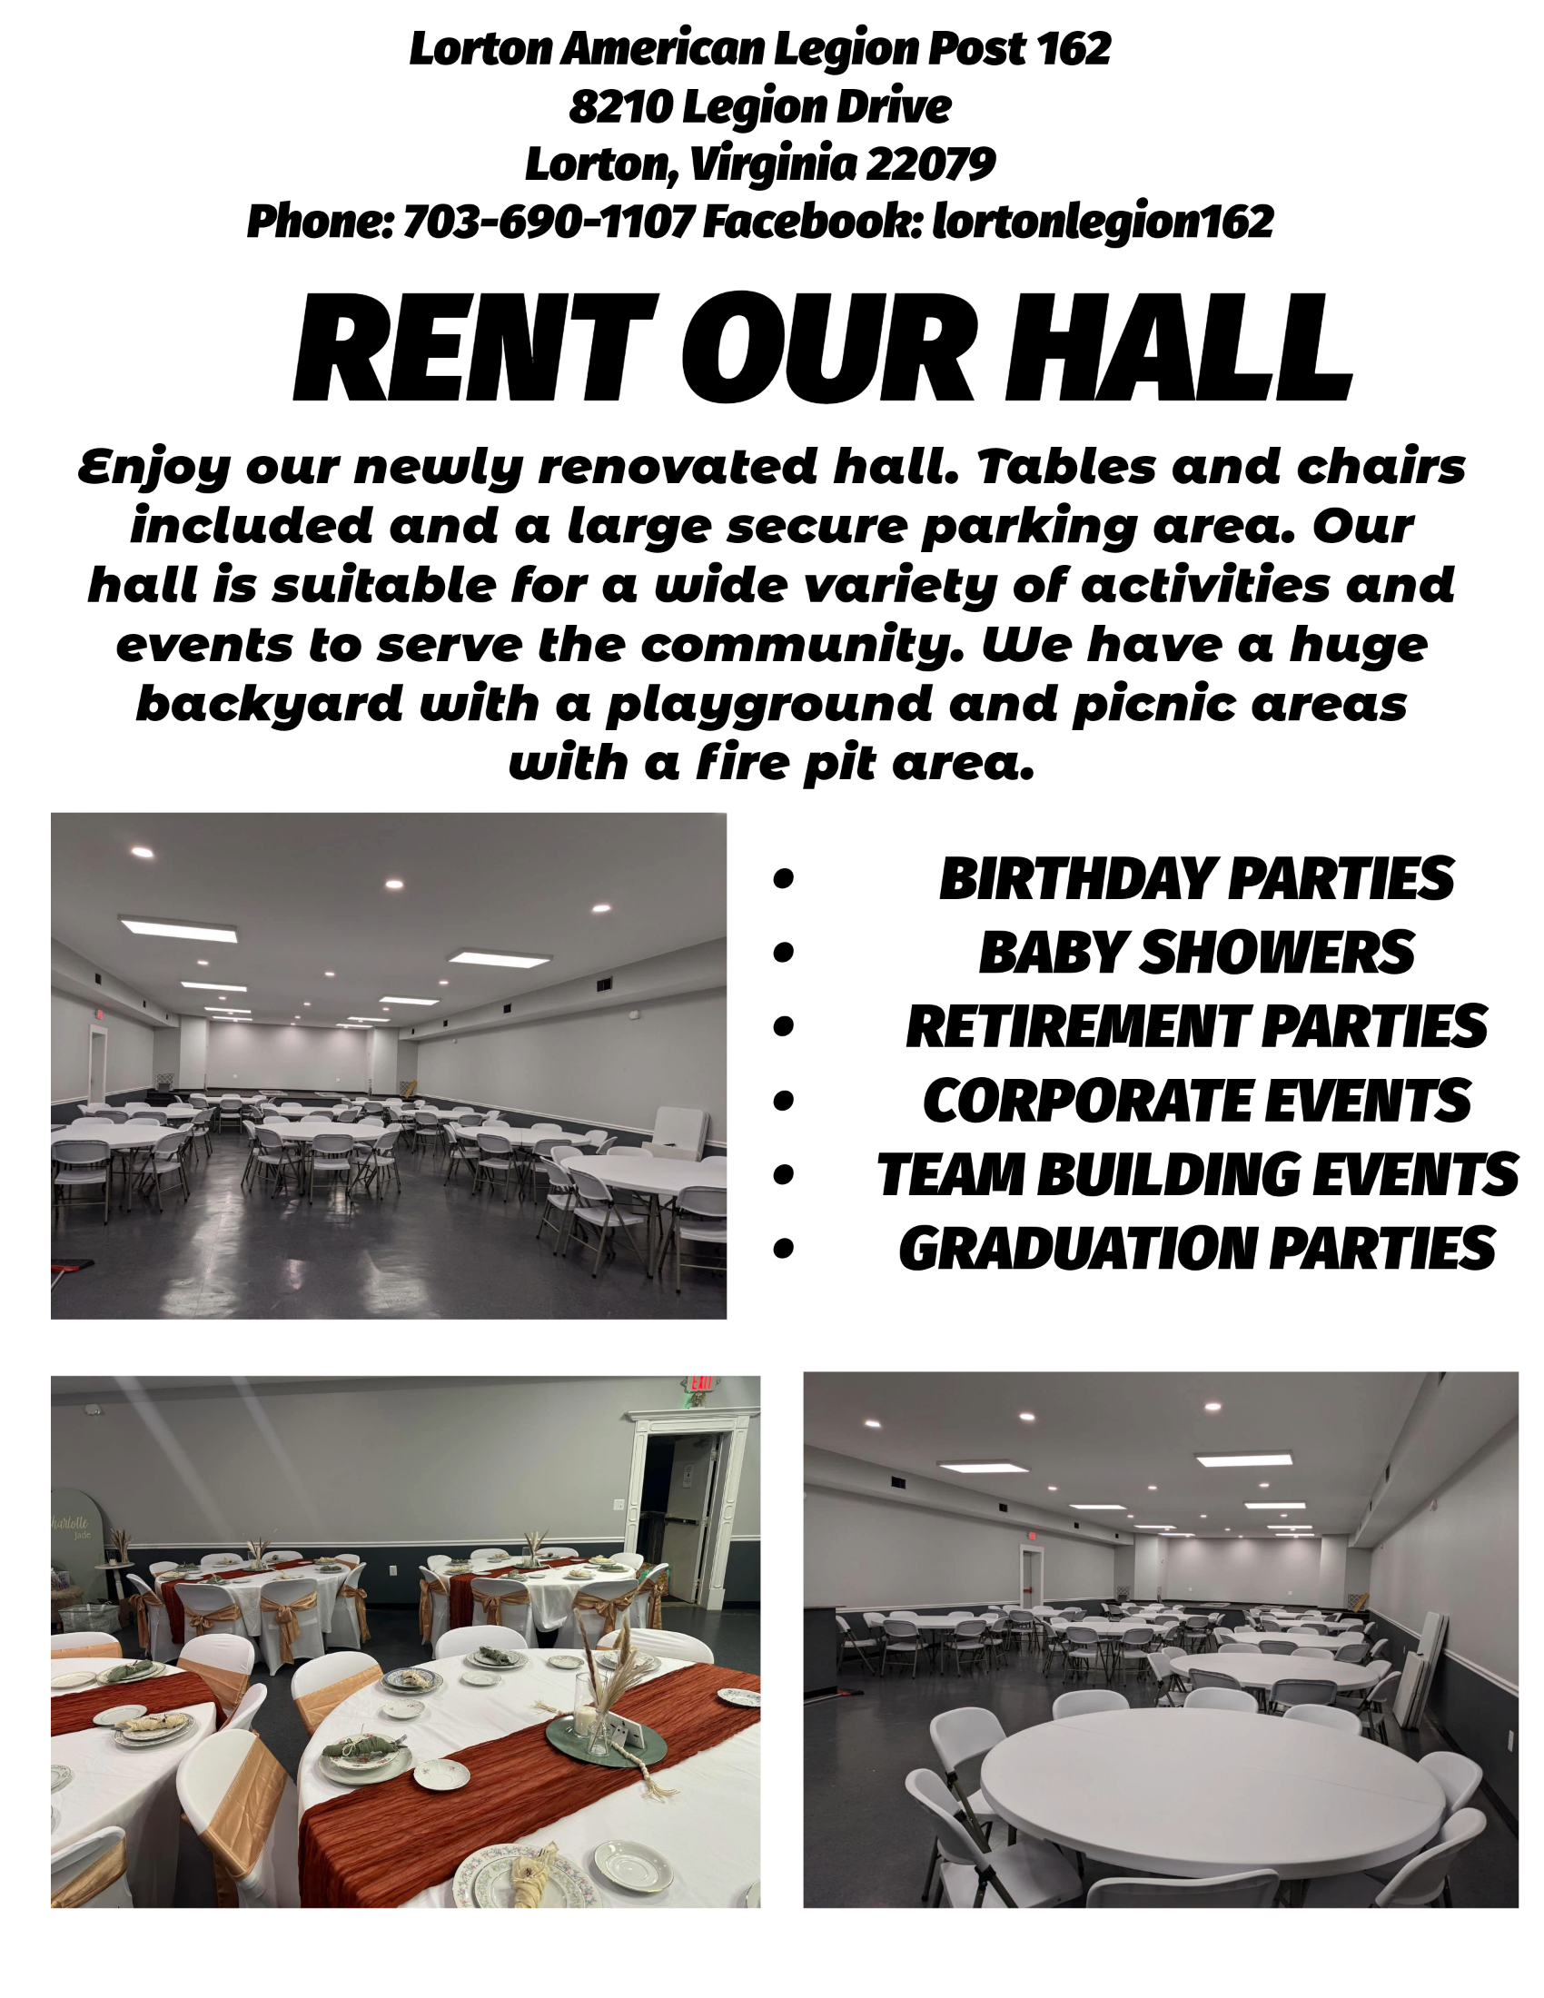

COMMANDERS COMMENTS

Legion Post 162,
We are looking forward to the events around the American Legion’s birthday this month! Kicking off the week, we will be holding a Chili Cookoff and Corn Hole tournament on Sunday, March 10th to kick off the week and I look forward to seeing many of you there! To finish out the Birthday Week, we’re hosting the Legion Birthday Party on Saturday, March 16th at 6pm, with the Tututi Band!!
Please stop by and say Hi, have a drink and participate in the following events: Trivia on March 12th and 28th, Karaoke on the 15th and a Gaming Tournament on the 22nd.
We are in the process of addressing our aging walk-in coolers and the concrete slab they are sitting on. Once we resolve these issues, we can refocus to the kitchen itself. We are also in the process of figuring out where best to put up some dart boards and if there is a practical way to bring a pool table into building.
The EXCOM is also working with the local High Schools for the Boys State program, in addition to the Youth Cadet Law Enforcement program. Michelle (2nd Vice) is heading up both programs this year and could use any assistance our members are willing to give her.
Nominations for the Executive Committee positions will be held in April and elections will take place in May.
As requested last month, please come forward and let us know if there is anything about OUR Post that you think needs to be addressed, whether it’s something to do with the actual building or what WE are doing. We would LOVE to hear from you. Our next General Membership meeting is scheduled for Thursday, March 21st at 6pm. If that day/time doesn’t work for you, please send us an email, letting us know your thoughts/ideas. Again, this is OUR post, and I want to make sure we are conducting events and doing things that YOU want.
Chris Warner
Interim Commander
Post 162

Your House UPDATE
The 2nd Vice’s Place to keep you informed
There are MANY folks that contribute to the upkeep and maintenance of Post 162 and I want to take a moment to thank each of them for their efforts. Through their tireless work, the Post House, YOUR HOUSE, remains a refuge for Veterans, Families, and Friends. To name each of you for your past work would run me out of room, so as we move forward, I’ll be working to give “shout outs.” But the first SHOUT OUT belongs to Vickie and Jenna…for, well A LOT.
THE ACTUAL UPDATE
- Beer Coolers – too hot to handle – the behind the bar cooler has received maintenance and will soon be joined by a new cooler…frankly we were running out of quick storage, and we know y’all don’t like warm beer.
- Walk-In Coolers – farewell to old friends – two new walk-in coolers will be installed in the next few months. One larger walk-in for beverages and a smaller walk-in for food. This is a rebalance which will allow us to keep our sippers happy while moving forward with our ongoing kitchen restoration efforts. The concrete slab under the existing walk-in coolers needs some TLC and that’s coming too.
- Wi-Fi – we’re WIRED but not because of too much coffee – Efforts to unwind our historic mess of tangled wiring are ongoing AND new antennas are being installed around the house to boost Wi-Fi signal. This corrects low Wi-Fi in the event hall.
- STEPS – the steps leading up to the event hall door were replaced to correct a safety issue identified by a member – keep those pesky items identified so we can continue to enjoy the house safely!
- TIMBER – I’d say something about “burning down the house,” but that’s not funny anymore!!! We split and stacked most of the remaining logs. What’s left are seats around the fire pit. There’s a stack of “short” wood…tiny logs…please burn this first in the pit. And if you get a wild hair…you can move the old wood from by the gate to the new stacking area under the tree…one or two pieces a visit would be a huge help.
UPCOMING HOUSE HONEY DOs
- CALLING of a HOUSE COMMITTEE – HEY YOU…YES, YOU! No, don’t look away…I mean YOU! We need you to participate in the new “HOUSE COMMITTEE.” This group of 5 will work to collect and identify items around the house that need some TLC. Then we will work to determine if the work can be done in-house by volunteers or if it needs to be contracted. Either way, this group will oversee the efforts. For instance, if a contractor needs to come in early, a committee member will escort them. Call or text Michelle TODAY at 601-926-0797 to sign up. Every effort you make helps our 200+ members.

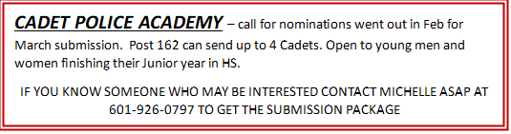

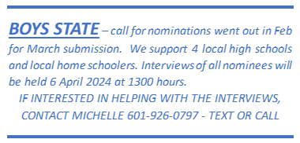

Past Events

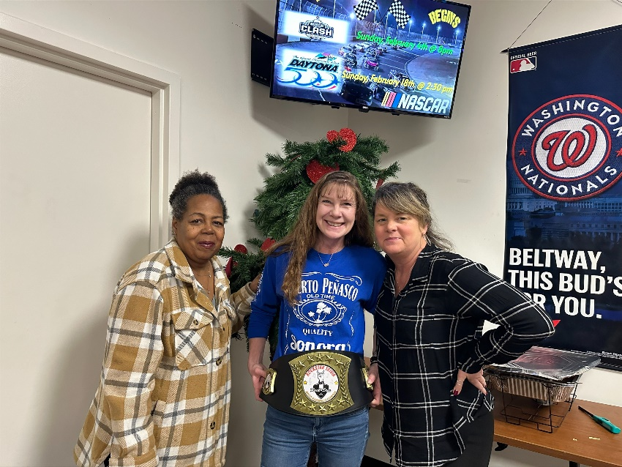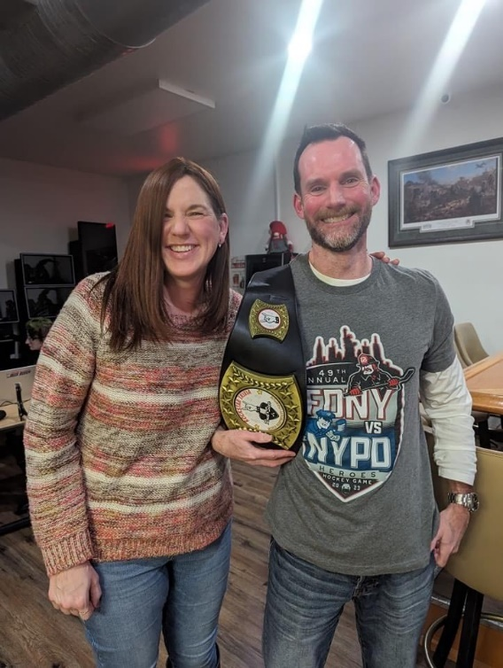

Trivia Night Winners!
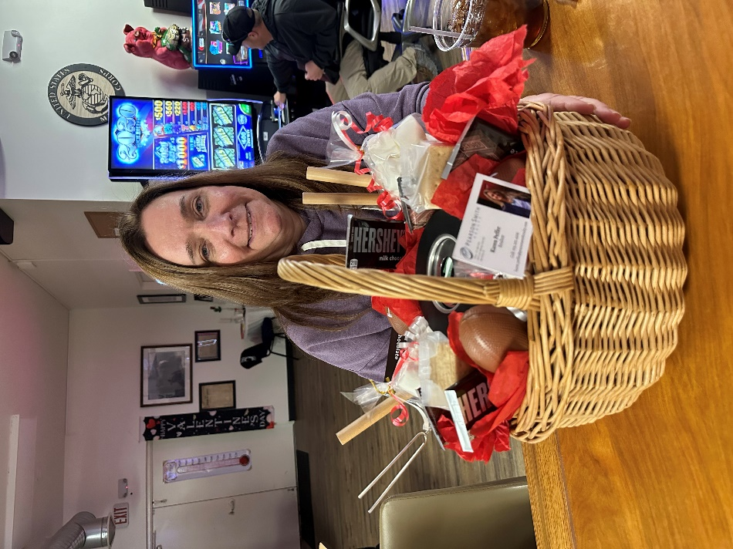
SuperBowl Party Kim Winner of Valentines Basket

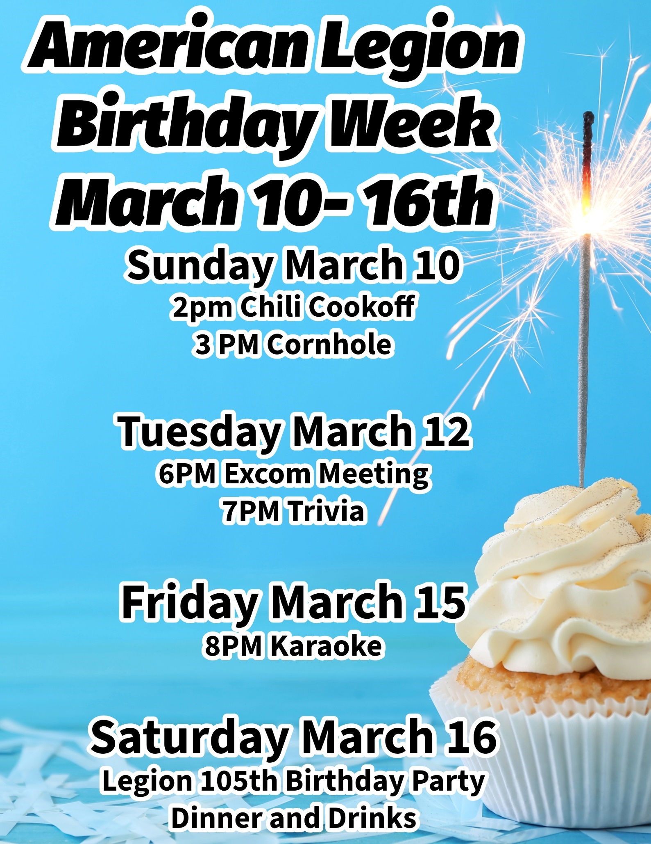



NEW MEMBERS
Legionnaires: Auxiliary: SAL:
Robert Jackson


Every month we pause to remember our brothers and sisters in arms who have fought the battles of Service but, alas, have moved onto Post Everlasting. Though they are gone, they are not forgotten.

AMERICAN LEGION POST 162

